**Vivekanand Education Society’s Institute Of Technology Department Of Information Technology**

**Project Review**

**Sem: V Academic Year : 2024-25**

Title: **GUMTREX**

Domain: **E** - **Commerce(Website)**

**Group Members:**

**Member1 : HIMANSHU NAIK (63)**

**Member 2: AMAN YADAV (60)**

**Member 3: NEERAJ RIJHWANI (64)**

**Member 4: PIYUSH KAMNANI (62)**

**Mentor Name: DIPTI KARANI**

* Introduction
* Problem Statement
* Objective of the project
* Functionalities
* Literature Survey
* Requirements of the system (Hardware, software)
* Use Case Diagram
* References in IEEE format
* **Welcome to Gumtrex** : Gumtrex is India’s consumer-to-consumer (C2C) platform, and the counters marketplace for pre-owned cars and motorbikes, second-hand mobile phones, and pre-loved personal and household goods.
* What's in Store:
  + Pre-loved cars and motorbikes for your next adventure.
  + Upgrade your phone without breaking the bank.
  + Give a new home to items with stories to tell.
  + Household Goods.
* Why Gumtrex?
  + Connect buyers and sellers directly in a friendly environment.
  + Enjoy a seamless and secure customer-to-customer experience.
  + Embrace a sense of community and trust while shopping.
* Easy and Fun:
  + User-friendly interface for effortless browsing and buying.
  + Sellers create detailed profiles for items, making it easy to find what you need.

Problem Statement

1)Many users were facing problems navigating through the important features that they wanted to use or the functions that they wished were more forgiving.

2 )Mobile Responsiveness: With the increasing use of mobile devices, optimizing the Gumtrex website for mobile responsiveness can be crucial. This could involve discussing responsive design, mobile app development, and strategies to ensure a seamless experience on smartphones and tablets.

3) Social Integration: Integrating social media features can encourage sharing, increase exposure for listings, and enhance user engagement. This might involve allowing users to share listings on their social media profiles or incorporating user reviews and ratings.

4)The Buying and Selling Processes: Design an intuitive interface that simplifies the process for sellers and enhances the search and discovery experience for buyers. Improve efficiency in finding desired items and connecting buyers and sellers effectively.

5) Promote Cost-Effective Choices: Empower users to make financially sound decisions by offering a wide range of pre-owned options at affordable prices, making it possible for individuals to access quality items without stretching their budgets.

6)In-App Delivery Integration: Collaborate with third-party delivery services to offer integrated delivery options directly within the Gumtrex app. This could allow users to choose delivery during the checkout process.

7)Data Analytics and Personalization: Utilizing advanced data analytics to understand user behavior, preferences, and trends can enable Gumtrex to offer personalized recommendations and targeted advertising, improving user engagement and satisfaction.

8)Enhanced User Experience: Continuously improving the user interface, mobile app functionality, and overall user experience can help retain existing users and attract new ones. This could involve incorporating new features, optimizing search algorithms, and streamlining the buying and selling processes.

9)Language Translation Services: Elevate the retail experience by offering robust support to both valued customers and dedicated store associates. Our cutting- edge services foster crystal-clear communication among diverse language speakers, fostering

Objective of Project

* Selling Used Items
  + Easily sell your old stuff like electronics, furniture, and clothes by creating listings with photos and prices.
  + Manage your listings, mark items as sold, and update details as needed.
* Buying Second-Hand Goods
  + Find great deals on used items like gadgets and clothes.
  + Search by category, price, and location to discover what you need.
  + See clear listings with pictures, descriptions, and seller info.
* Local Services
  + Local businesses can offer services like home repairs and event planning.
  + Users looking for services can explore listings and directly contact service providers.
* Job Listings
  + Some regions have job listings on Gumtrex where employers can post job openings and

job seekers can find employment opportunities.

* Real Estate Listings
  + Rent or buy properties like homes and apartments.
  + Listings provide property info, photos, prices, and contact details.
* Business Opportunities
  + Entrepreneurs using Gumtrex can advertise franchise, partnership, or investment opportunities.
  + Interested individuals can get in touch for more information.
* Promoting Small Businesses
  + Small businesses and startups can showcase and sell products.
  + Listings include product details, prices, pictures, and contact info.
* Vehicle Listings
  + People often use Gumtrex to buy or sell vehicles, including cars, motorcycles, and other modes of transportation.
  + Listings offer specs, pictures, prices, and seller contact info.

**Literature Survey**

| **Title** | **Author** | **Year** | **Discussion** |
| --- | --- | --- | --- |
| Reviewchain | Martens.D | 2019 | A blockchain model for secure e-commerce reviews. Uses Ethereum blockchain to store unchangeable reviews, prevents manipulation. Authenticated reviewers with good history influence product prices. Focus on countering fraud reviewers, building trust. |
| A decentralized marketplace application on the Ethereum blockchain | Prasad, R. V | 2021 | The paper introduces a decentralized marketplace on Ethereum blockchain to tackle e-commerce issues. It enhances security, transparency, and trust through smart contracts. Benefits include reduced fees and intermediary elimination. This model  addresses challenges in traditional platforms. |

| ETTF, a trusted trading framework using blockchain in e-commerce. | Xie W. | 2022 | This paper introduces the ETTF (Trusted Trading Framework) model, which utilizes blockchain technology to enhance the security of transactions in e-commerce. The authors discuss the challenges of existing e-commerce platforms and how blockchain can provide a trusted and secure environment for trading. The ETTF model aims to improve the security of transactions performed over the network. The paper discusses the use of blockchain for data protection, authentication, and verification of transactions. |
| --- | --- | --- | --- |

**Software Requirements:**

* Operating System: Windows XP, Windows Vista, Windows 7, Windows 8, Windows 10, Windows Server 2003, Windows Server 2008, Windows Server 2012.
* Version Control and Collaboration: Git and GitHub.
* Communication and Collaboration: Slack, Microsoft Teams.
* Continuous Delivery and DevOps: Kubernete
* Agile Framework, .NET Framework version 3.5,PHP, MERN .

# Hardware Requirements:

* 1 gigahertz (GHz) or faster x86-bit or x64-bit processor
* 512 MB RAM minimum
* 20 MB of hard-disk space for program installation
* A BioMetric Device (if not inbuilt in the system)

**Use Case Diagram**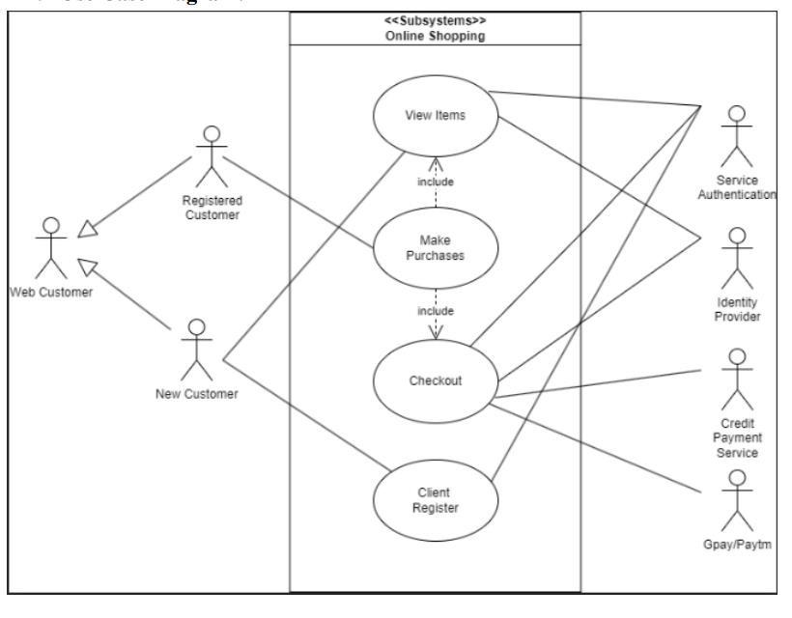

**REFERENCES**

1. Martens, D."Reviewchain: A blockchain-based model for secure and private product reviews." 2019 IEEE International Conference on Blockchain (Blockchain). IEEE, 2019.

2 Prasad, R. V. "A decentralized marketplace application on the Ethereum blockchain." 2018 IEEE International Conference on Decentralized Applications and Infrastructures (DAPPS). IEEE, 2021.

3 Xie, W."ETTF, a trusted trading framework using blockchain in e-commerce." 2018 IEEE International Conference on Internet of Things (iThings) and IEEE Green Computing and Communications (GreenCom) and IEEE Cyber, Physical and Social Computing (CPSCom) and IEEE Smart Data (SmartData). IEEE, 2022.